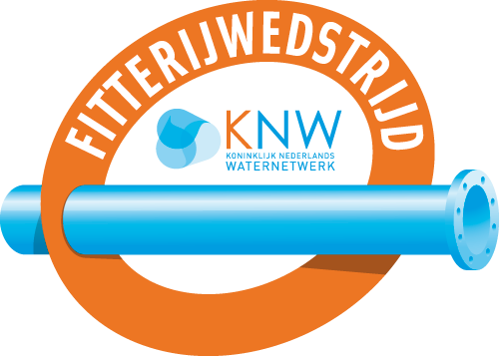
13e Dutch Open KNW Fitterijwedstrijden
5 - 8 November 2019
Aquatech, Amsterdam RAI
APPLICATIONFORM
Please fill in this form and return before September 1st to: fitterijwedstrijd@waternetwerk.nl
CONTACTGEGEVENS
Companyname participant:
Name contact:
E-mailadress contact:
Phonenumber contact:
Company adress:
MEN’S – TEAM 1 | NAME |  | BIRTHDATE
DRILLER
FEEDER
COACH
MEN’S – TEAM 2 | NAME |  | BIRTHDATE
DRILLER
FEEDER
COACH
MEN’S– TEAM 3 | NAME |  | BIRTHDATE
DRILLER
FEEDER
COACH

WOMEN’S – TEAM 1 | NAAM | BIRTHDATE
DRILLER
FEEDER
COACH
WOMEN’S – TEAM 2 | NAAM | BIRTHDATE
DRILLER
FEEDER
COACH
WOMEN’S – TEAM 3 | NAAM | BIRTHDATE
DRILLER
FEEDER
COACH

